CLASSROOM COPY
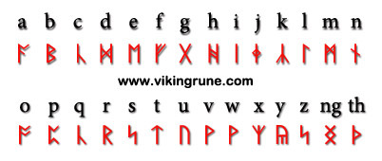

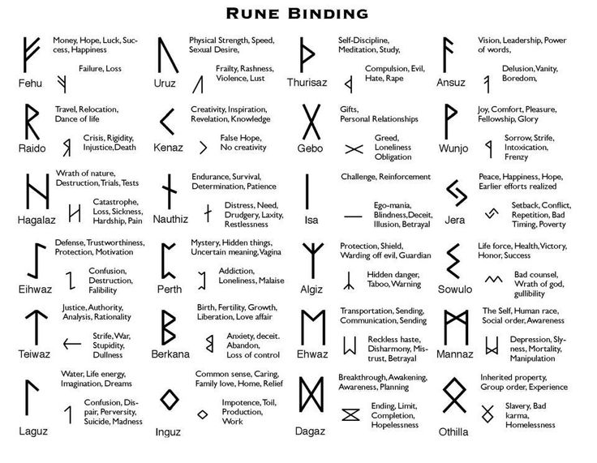

Bluetooth communication protocol
Bluetoothlogo with runes H and B, referring to Harald Bluetooth
"Bluetooth" now commonly refers to the Bluetooth wireless specification design started by Ericsson, Nokia, Intel and Toshiba to enable cable-free connections between computers, mobile phones, PDAs, printers, etc. The Bluetooth communications protocol in these devices is named after the king, because he unified Denmark and Norway much like the technology whose goal was to unify computers and cellular phones.
The Bluetooth logo consists of the younger futhark runes, also known as the Nordic runes for his initials, H ( hagall) and B ( berkanan) (Long-branch runes version). The younger futhark rune names have been documented; "hagalaz" and "berkana" etc. are posited elder futhark rune names in a posited proto-Germanic.

The nickname "Bluetooth”
Harald's nickname "Bluetooth" (blátǫnn) first documented appearance is in the Chronicon Roskildense from 1140. The usual explanation is that Harald must have had a conspicuous bad tooth that appeared "blue" (i.e. black, as "blue" meant dark).
Another explanation, is that he was called Thegn in England (corrupted to "tan" when the name came back into Old Norse). In England, Thane meant chief. Since blue meant "dark", his nickname was really "dark chieftain".
A third theory, according to curator at the Royal Jelling Hans Ole Mathiesen, was that Harald went about clothed in blue. He theorized that blue color was the most expensive, so by walking in blue Harald underlined his royal dignity. This theory has since been disproven as the dye the Norse used to make blue came from woad, which is a common plant. It is easy to use for dying and would have been utilized for common, everyday textiles.

