SOUND IN CINEMA:  "Films are 50% visual and 50% sound. Sometimes sound even overplays the visual." -- Film Director, David Lynch  "The lesson is, don't play the visual -- play the emotion." -- Sound Designer, Al Nelson | 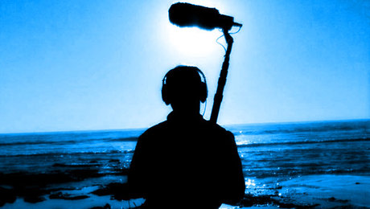

Below, you will find videos and clips to help you understand the way films use sound to create meaning, enhance impact, and create the illusion of reality:
BASIC CONCEPT #1 -- DIEGETIC MUSIC AND SOUND IS USED TO FURTHER THE STORY OR PROVIDE SETTING: https://www.youtube.com/watch?v=FT_E9Jm_Lk8&t=1s&ab_channel=FoldingIdeas
The following clip illustrates the move from diegetic to non-diegetic music in a film. Diegetic music can be heard by the characters and is used to further the story and add to the realism of the setting. The second, non-diegetic, score music cannot be heard by the characters and is used (again) to create tone and characterization. (Casablanca)
https://www.youtube.com/watch?v=cOeFhSzoTuc
BASIC CONCEPT #2 -- "AMBIENT SOUND," "PRESENCE," OR "NAT SOUND" CREATES OR ENHANCES REALITY OF THE SETTING AND AIDS WITH THE AUDIENCE'S SUSPENSION OF DISBELIEF: The natural, or ambient, sounds in a location (everything from the hum of a florescent light to the sounds of traffic on a nearby highway) aren't usually noticeable until they're missing. Filmmakers make purposeful choices about the background sounds they include. The following video illustrates the importance of: presence," "nat sound," or "ambient sound." (Emma Watson clip)
Ambient Sound Clip
﻿
BASIC CONCEPT #3﻿ -- MUCH OF THE DIALOGUE HEARD IN A FILM IS NOT RECORDED AT THE SAME TIME AS THE VISUALS. IT IS RECORDED LATER AND ADDED INTO THE FILM IN A PROCESS CALLED "ADR" OR "LOOPING": The next clip illustrates the concept of "looping" or Automated Dialogue Replacement (ADR).
https://youtu.be/lP_673W270Y
BASIC CONCEPT #4 -- TO SAVE MONEY, MANY BACKGROUND SOUNDS ARE ADDED FROM PRE-RECORDED SOUND EFFECTS LIBRARIES: "Library" or pre=recorded sounds and effects are cheaper than recording new, original sounds. These sounds get used over and over in different films over many years. Some get used so often they get famous. The following clip illustrates one such sound, known as "The Wilhelm Scream."
https://youtu.be/ksKRYSixSVk
BASIC CONCEPT #5 -- MOST DIEGETIC SOUNDS ARE CONSTRUCTED AND ADDED POST-PRODUCTION IN A PROCESS CALLED "FOLEY": Foley is the art of laying in all the little sounds (mainly footsteps, cloth, and props) that create the illusion of reality. In most big productions, over 80% of the sounds the audience hears were added in post-production by Foley artists and sound editors. The following video is an excellent demonstration of how the Foley and ADR processes work together.
https://youtu.be/U_tqB4IZvMk
Watch with your ears activity;
https://www.youtube.com/watch?v=kavxsXhzD48&t=435s&ab_channel=Nerdwriter1

Soundtrack vs. Score
Film soundtracks are songs by various artists that are chosen to be played, usually for only a few seconds, and are often released for sale as a soundtrack, however, many songs are usually left off of the released album which is frustrating!
https://www.youtube.com/watch?v=i19Y7HnW38U

Film scores are classically composed (instrumental), and are originally composed for specifically for the each film. Also, the score is not just one track but many tracks with a continued theme, tone, character persona, etc. Think about how Darth Vader has his own music track, but that track is obviously in the same vein as the general Star Wars theme.
(30 most famous scores clip)
Score the Score Clip
https://www.youtube.com/watch?v=UeSKoWCPCFI

